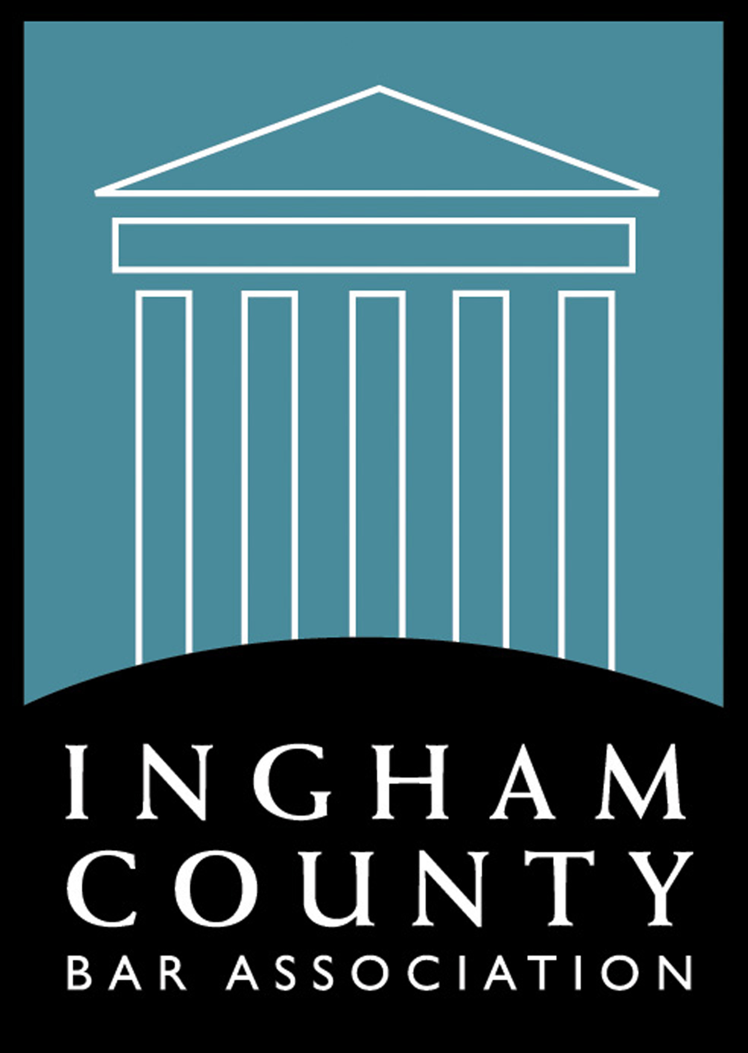
Ingham County Bar Association
Semi-Annual Bench-Bar Conference
Saturday, February 1, 2020 - 8:00 a.m. – 12:30 p.m.
Veterans Memorial Courthouse
313 W. Kalamazoo Street - Lansing, Michigan 48901
Space is limited
Casual Attire Recommended

Member Free # ______
Non-Member $20.00 # ______
Date: ___________
Name:_______________________________________________
Firm Name: ___________________________________________________________
Address: _____________________________________________________________
City: ____________________ State: _______________ Zip Code: _____________
Email Address: ________________________________________________________
(We must have email address to confirm your reservation)
Phone: _______________________________________________________________
Check # _______________________ Check $ _______________________________

ICBA DOES NOT TAKE PHONE registrations please complete the form and return via fax, email or through the ICBA website. Use an additional sheet if necessary, to provide additional names.
(If you are unable to attend and are registered/paid to attend you may send a replacement from your firm.)
**Please complete a separate form for each member of your Firm/Company.
Please check all that apply
□ I am a Member □ Non-Member □ Sponsor □ Media □ Committee Member

□ Law Student Member □ Law Student Non-Member □ Judge □ Other

Please select one session: □ Civil Motion Practice □ Family Law □ Criminal Law

Mail or fax back to: ICBA, PO Box 66, Grand Ledge MI, 48837 – Phone: 517-627-3938, Fax: 517-627-3950. Please register & pay in advance to secure your reservation – email: registrations@inghambar.org

Updated 10-3-19 vls

