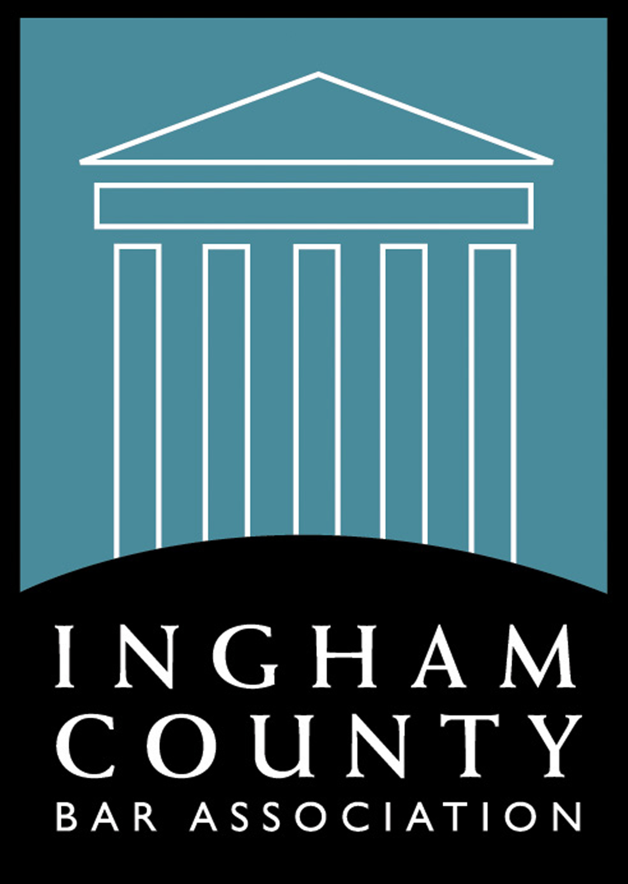
Sponsorship
Ingham County Bar Association
Semi-Annual Bench-Bar Conference
Saturday, February 1, 2020
8:00 a.m. – 12:30 p.m.
Veterans Memorial Courthouse
313 W. Kalamazoo Street
Lansing, Michigan 48901

Sponsorship - $300.00

* Company name in email marketing
* Company name displayed at event
* Listing in BRIEFS
* List of attendees

Sponsor Deadline: January 15, 2020

Marketing Contact:_________________________________________________________________
Firm/Company:____________________________________________________________________
Please list company name exactly like it should appear on sponsor sign.

Address:__________________________________________________________________________
City: ____________________________ State: _______________ Zip Code:__________________
Email: ____________________________________________________________________________

Check # ________________________ Check $ __________________________

Name of who will attend: _____________________________________________________________
*Email:____________________________________________________________________________

Mail or fax back by January 15, 2020 to: ICBA, PO Box 66, Grand Ledge MI, 48837 –
Phone - 517-627-3938, call or email questions to registrations@inghambar.org Fax - 517-627-3950

10-3-19 vls updated

