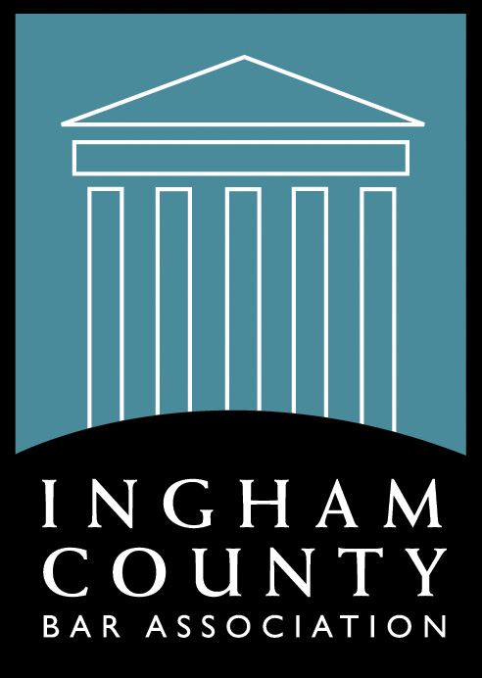
Ingham County Bar Association
Eleventh Annual “Meet the Judges” Reception
Michigan Supreme Court Justices,
Michigan Court of Appeals Judges,
Federal Judges, Local Judges, Administrative Law Judges,
Tribal Judges, and Local Referees have been invited to attend.
Thursday, January 20, 2022
5:30 p.m. – 7:30 p.m.
Lansing Brewery Company
Room: Stockhouse – 518 E Shiawassee, Lansing, MI 48912

Reception Attendance Fees
Member $35.00 (After January 12, 2022 - $40.00) Anyone who registers at the member rate but is not a member will be invoiced the difference.
*Non-Member $55.00, which includes membership in ICBA (After January 12, 2022 - $60.00)
*Law Student $10.00, which includes membership in ICBA (After January 12, 2022 - $20.00)
Onsite registrations (day of event): Member $45.00, Non-member $65.00, Students $25.00

Names must be received 24 hours prior to the event, otherwise they will be treated as an on-site registrant and late fees will apply.

This special event is one of our most popular and will provide members of the legal community an opportunity to network with respected judges.

Hors d’oeuvres will be served and a bar with two beverage tickets will be provided.
Capacity is limited so please be sure to register for this special event today!

Name ___________________________________________________________________
Company or firm name _____________________________________________________
Address _________________________________________________________________
City/State/Zip ____________________________________________________________
Phone Number ____________________________________________________________
E-mail Address ___________________________________________________________
 | ICBA Member | $ 35.00 | Anyone who registers at the member rate but is not a member will be invoiced the difference.
 | Non-Member | $ 55.00 * | * Includes ICBA membership and registration fee. Savings up to $100.00 or full membership of $130.00. Depending on member category. First time members will automatically become a member of ICBA for the remainder of the fiscal year.
 | Law Student | $ 20.00 *
 | TOTAL Amount Enclosed | $ | **Tickets will not be mailed**  **Please check in at the door upon arrival**

Check # __________________ Check $ _____________________

Cancellations will be accepted up to 72 hours prior to the event, less a $25.00 administration fee. Return completed forms with checks made payable to ICBA, P.O. Box 66, Grand Ledge, MI 48837; Fax 517-627-3950; Phone 517-627-3938

* (No phone registrations) * Payment must be received to be considered registered. * All non-members must complete the attached membership application and return it to ICBA with this registration form. 7-12-2022 mh

