Sponsorship Form
Ingham County Bar Association
Tenth Annual “Meet The Judges” Reception
Michigan Supreme Court Justices,
Michigan Court of Appeals Judges,
Federal Judges, Local Judges, Administrative Law Judges,
Tribal Judges, and Local Referees have been invited to attend.

Thursday, January 20, 2022
5:30 p.m. – 7:30 p.m.
Lansing Brewing Company
Room: Stockhouse – 518 E Shiawassee
Lansing, MI 48912
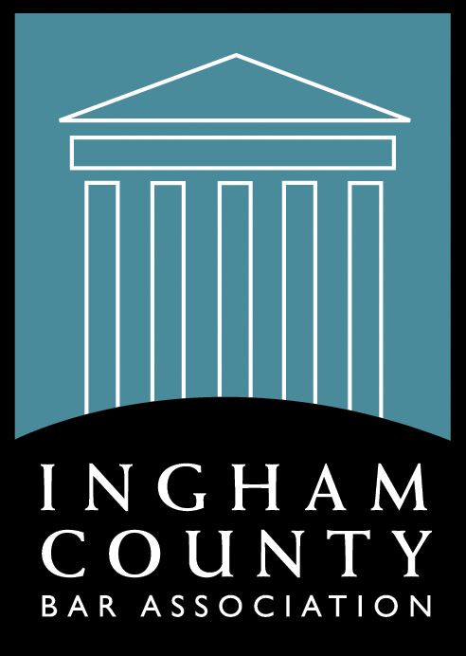

Each paid sponsorship entitles the sponsor admission to the event. The sponsor will be assigned a Judge which the sponsor will introduce at the event. The planning committee will assign sponsors to the Judges. The firm or company name will be listed on all event advertisements. The firm or company name will also be displayed at the event and listed in the ICBA newsletter. (Deadline is January 7, 2022)

Date: ________________
Name:__________________________________________________________________
Firm/Company: __________________________________________________________
Address: _______________________________________________________________
Email: __________________________________________________________________
Payment (Via check)
Phone: __________________________________________________________________
Check # ________________________ Check $ ___________________________

______ please add my firm/company to be a sponsor at $295.00

Make check payable to ICBA and mail or fax back to:
ICBA, PO Box 66, Grand Ledge, MI 48837 – Phone - 517-627-3938, Fax - 517-627-3950

Updated 7-13-2021 mh

